Binary Information
Binary Name => good kitty
Language => C/C++
Arch => x86x64
Platform => Unix/Linux
$ file crack
crack: ELF 64-bit LSB pie executable, x86-64, version 1 (SYSV), dynamically linked, interpreter /lib64/ld-linux-x86-64.so.2, BuildID[sha1]=8c584d707909182cb49dab6ebe51cca2217ab1ed, for GNU/Linux 3.2.0, not stripped

Analysis

Static Analysis
Below is the disassembly of the main(). I have only pasted the essential part
.................................................. (SNIP) ..................................................
0x00005555555554f0 <+580>: test al,al
0x00005555555554f2 <+582>: je 0x555555555562 <main+694>
0x00005555555554f4 <+584>: lea rdi,[rip+0xb14] # 0x55555555600f
0x00005555555554fb <+591>: call 0x555555555090 <puts@plt>
0x0000555555555500 <+596>: mov rax,QWORD PTR [rsp+0xa8]
0x0000555555555508 <+604>: sub rax,QWORD PTR fs:0x28
0x0000555555555511 <+613>: jne 0x555555555570 <main+708>
0x0000555555555513 <+615>: mov eax,0x0
0x0000555555555518 <+620>: add rsp,0xb8
0x000055555555551f <+627>: pop rbx
0x0000555555555520 <+628>: pop rbp
0x0000555555555521 <+629>: ret
0x0000555555555522 <+630>: mov edx,DWORD PTR [rsp+0xc]
0x0000555555555526 <+634>: add edx,0x1
0x0000555555555529 <+637>: mov DWORD PTR [rsp+0xc],edx
0x000055555555552d <+641>: mov edx,DWORD PTR [rsp+0xc]
0x0000555555555531 <+645>: movsxd rdx,edx
0x0000555555555534 <+648>: cmp rdx,rax
0x0000555555555537 <+651>: jge 0x5555555554d9 <main+557>
0x0000555555555539 <+653>: mov edx,DWORD PTR [rsp+0xc]
0x000055555555553d <+657>: cmp edx,0x7
0x0000555555555540 <+660>: ja 0x5555555554d9 <main+557>
0x0000555555555542 <+662>: mov ecx,DWORD PTR [rsp+0xc]
0x0000555555555546 <+666>: mov edx,DWORD PTR [rsp+0xc]
0x000055555555554a <+670>: movsxd rcx,ecx
0x000055555555554d <+673>: movsxd rdx,edx
0x0000555555555550 <+676>: movzx ebx,BYTE PTR [rsp+rdx*1+0x10]
0x0000555555555555 <+681>: cmp BYTE PTR [rsp+rcx*1+0x60],bl
0x0000555555555559 <+685>: je 0x555555555522 <main+630>
0x000055555555555b <+687>: mov BYTE PTR [rsp+0xb],0x0
0x0000555555555560 <+692>: jmp 0x555555555522 <main+630>
0x0000555555555562 <+694>: lea rdi,[rip+0xa9b] # 0x555555556004
0x0000555555555569 <+701>: call 0x555555555090 <puts@plt>
0x000055555555556e <+706>: jmp 0x555555555500 <main+596>
0x0000555555555570 <+708>: call 0x5555555550b0 <__stack_chk_fail@plt>
End of assembler dump.
gef➤ x/s 0x555555556004
0x555555556004: "bad kitty!"
gef➤ x/s 0x55555555600f
0x55555555600f: "good kitty!"
gef➤

Program Workflow
- Takes a password as user input.
- If password is correct good kitty! is printed otherwise bad kitty! is printed.

Dynamic Analysis
- I setup the breakpoints at main() and at 0x00005555555554f0 <+580>: test al,al.
gef➤ i b
Num Type Disp Enb Address What
1 breakpoint keep y 0x00005555555552ac <main>
breakpoint already hit 1 time
2 breakpoint keep y 0x00005555555554f0 <main+580>
- I ran the program after that, and I noticed somewhere between breakpoint 3 and breakpoint 4 there was a unique string which got placed inside the stack. Below is the image of the stack condition when that happens.

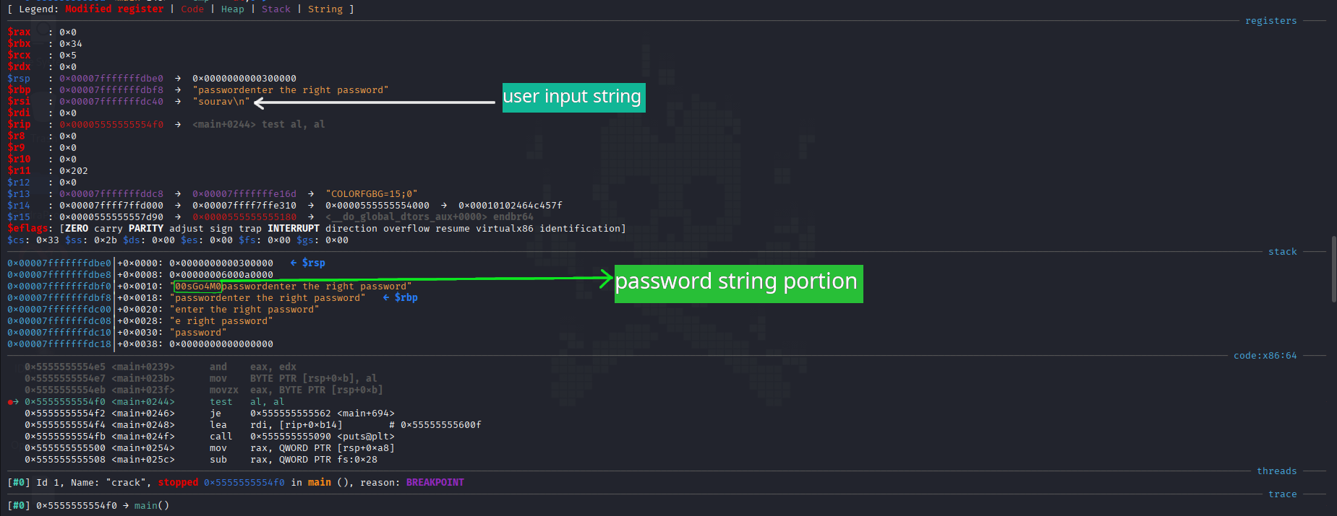

Testing our input
$ ./crack
enter the right password
00sGo4M0
good kitty!
Yeah!!! we were able to solve this crackme challenge.

